**Final Project Proposal:**

**Movie Explorer Web Application**

1. **Overview:**

**What is the problem we are trying to solve?**

The Movie Explorer web application aims to provide users with an easily accessible platform to discover and explore the top 100 movies according to IMDb. Many users often struggle to find high-quality movies to watch, especially from a vast selection available online. This app seeks to solve this problem by displaying a list of the best-rated movies and presenting them in an intuitive and user-friendly interface.

**Why are we doing this?**

I am developing this application to simplify the process of discovering top-rated movies, saving users’ time and effort in finding quality movies. Additionally, by showing the IMDb Top 100 movies, I aim to celebrate cinematic excellence and promote a deeper appreciation for the art of filmmaking.

1. **Who is the audience?**

The target audience for the Movie Explorer web application includes movie enthusiasts, casual viewers looking for recommendations, and anyone interested in exploring critically-acclaimed films. This application caters to a diverse range of users who appreciate high-quality cinema and seek convenient ways to discover new movies.

1. **List of Major Functions:**

* Display the IMDb Top 100 movies list.
* Provide detailed information about each movie, including title, genres, release year, director, short description, and IMDb rating.
* Allow users to search for movies by title, genre, director, release year.
* Provide YouTube movie trailer and IMDb links.
* Implement a responsive design to ensure optimal user experience on both mobile and desktop devices.
* Enable users to bookmark favorite movies for future reference.

1. **Wireframes**

Mobile:

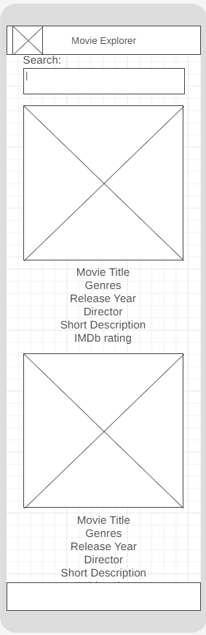

Desktop:

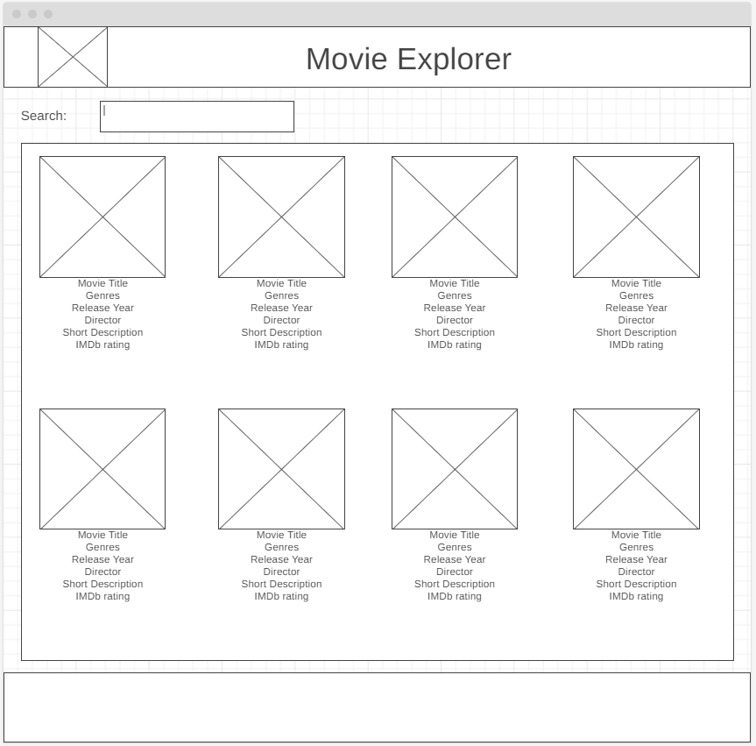

1. **Data Sources:**

The primary data source for the Movie Explorer web application will be the IMDb Top 100 Movies API, which provides access to information about the top-rated movies on IMDb. Additionally, I may utilize local storage to store user preferences and bookmarked movies for a personalized experience.

IMDb Top 100 Movies API: <https://rapidapi.com/rapihub-rapihub-default/api/imdb-top-100-movies>

1. **Initial Module List:**

* Movie List Module
* Movie Details Module
* Search Module
* Bookmark Module

1. **Colors/Typography/Specific Element Styling:**

**Color Scheme:**

Primary Color: Dark Blue (#0E2348)

Accent Color: Gold/Yellow (#FFD700)

Secondary Color: Light Gray (#EDEDED)

**Typography:**

Heading Font: Playfair Display

Body Font: Roboto

**Specific Element Styling:**

I will incorporate subtle visual elements inspired by classic movie aesthetics, such as film reel icons, popcorn motifs, or subtle film grain textures. I will also use CSS animations on different elements in the web application.

1. **Schedule:**

**Week 1: Development**

* **Day 1-2: Frontend - Movie List Module**
  + Implement basic UI components for displaying the movie list.
* **Day 3-4: Frontend - Movie Details Module**
  + Develop UI components to show detailed information about each movie.
* **Day 5: Backend - API Integration**
  + Integrate IMDb Top 100 Movies API.

**Week 2: Development**

* **Day 6-7: Backend - Search Module**
  + Implement search functionality for finding movies by title, genre, director, or release year.
* **Day 8-9: Frontend - Bookmark Module**
  + Develop UI components and functionality for users to bookmark favorite movies.
* **Day 10: Backend - Additional Features**
  + Implement any additional backend features as needed.

**Week 3: Testing and Optimization**

* **Day 11-12: Testing and Debugging**
  + Conduct testing and fix any bugs.
* **Day 13-14: Optimization**
  + Optimize code for performance.

**Milestones:**

1. Frontend and backend modules for displaying movie list and details completed.
2. Search and bookmark modules implemented.
3. Testing, debugging, and optimization finished.
4. **Trello Board:**

<https://trello.com/invite/b/K2uUoRQB/ATTI964d8c10ac38d8a7b392d6484e5ff2b228905501/movie-explorer>